Welcome to Cottonwood Creek’s GAP Class for Parents
GAP for Parents - Week 11 – The Bible

The popular view of Christianity may be driven more by Hollywood than by scripture. Most Americans would say they believe in God, but that all “good” people go to Heaven. But a growing atheist community is screaming that there is no God and that the Bible is just a collection of ancient myths. So, what is true? All of Christian doctrine depends on Jesus being the Son of God, Son of Man, killed and supernaturally resurrected to pay for our sin, as recorded in the New Testament. So it’s no surprise that an anti-Christian culture relentlessly attacks the reliability of the Bible. Good news, though! Resources on the reliability of the Bible are almost unlimited. Detective J Warner Wallace, for example, has produced a powerful case through his explanation of “the chain of custody” of evidence that the New Testament is indeed reliable and that Jesus was and is the Alpha and Omega of the Bible.

Last Meeting (Week 10)
What are the unquestioned historic facts supporting the resurrection?
- _________________________________________
- _________________________________________
- _________________________________________
- _________________________________________

This Week – The Bible:
How
What do you believe about the Bible? The Bible is…
______________________________ _______________________________
______________________________ _______________________________

8 Conversations about the Bible:
- Why these 66 books
- Why not other books
- Who were the authors
- What was in ‘autographs’
- Errors & contradictions
- Slavery!
- Rape!
- Human sacrifice!
(also, remember the “genocide of the Canaanites” from earlier)

Before we answer those questions, consider this.
Do you “need” the Bible to be a Christian?

What is “The Canon”?
“… a list of authoritative books more than an authoritative list of books.” - Bruce Metzger
Criteria:
- Written by a prophet of God?
- Confirmed by acts of God or someone who was confirmed as an eyewitness?
- Accepted [from the beginning] by the people of God?
Note: Canon not required to prove the resurrection!

What about the other gospels, sometimes called the lost gospels?
- Not written in same time period as eyewitnesses
- Fraudulent, plagiarized
- Heretical
- Clearly contradictory
Conclusion: The New Testament is the one Jesus promised.
Why is the Catholic Bible different?
Apocrypha added 1500 years later in response to Protestantism
Powerful evidence confirming authorship and authority of N.T.
- 25 of the 27 books were quoted by 110 AD
- Gospels and Acts cited during lives of apostles
- Quoted as authoritative and unique
- Collected early in one volume
- Publically read & expounded
- Commentaries written [early & often]
- Opponents admitted Gospels written by disciples
- None of the other so-called gospels were treated this way
Also, early church fathers quoted Gospels extensively.

Who were the authors?
Critics say the gospels are anonymous
And that more educated people wrote them much later
e.g. John was just an uneducated fisherman and couldn’t have written John
Video: Dillahunty on the authorship of Matthew

Video: Dr. Darrell Bock, DTS, on the authorship of the gospels

Critics say:
- We don’t know what was in the original manuscripts because we don’t have any
- There are 100’s of thousands of errors in the manuscripts
- More errors than there are words in the N.T.
- Like the “telephone game”
  - Verbal telling & retelling created a legend
  - After the gospels were written
    - Countless scribal errors
    - Intentional changes & additions

Compared to other ancient writings
- Earlier manuscripts
- More manuscripts
- More accurately copied
- More abundantly supported manuscripts
Not like the “telephone game” because not linear
But what about the outright contradictions?
Video: 2 different genealogies in Matthew and Luke. The criticism and the explanation.

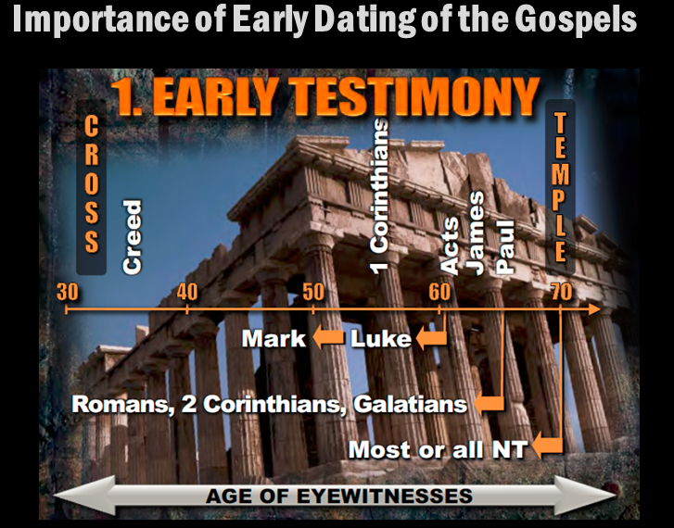

A+ for Biblical Accuracty – Archaeology and History
- 84 historically-confirmed eyewitness details in Acts
- Luke includes several others in his Gospel
- 59 historically-confirmed or historically probable eyewitness details in John
- N.T. documents cite more than 30 people confirmed by secular sources or archaeology
Critics said there was no evidence for many of the people and places in the N.T. (and O.T.)
Over and over again, archaeology finds things like:
- Ossuary of Caiaphas
- Evidence of Pilate (literally carved in stone)
- Crucifixion nails through bones of victims
Next week: Does the Bible condone slavery, rape and human sacrifice?

Take Away:
- “66 books by 40 authors, an extraterrestrial message from outside of space and time.” – C Missler
- No reasonable doubt that the N.T. Canon is the 27 books recognized as scripture by the early church.
- The “DaVinci Code” story of the Council of Nicaea is a totally bogus account of the Canon.
- The Gospels were written much earlier than critics claim.
- The core gospel doctrine can be traced back to the first few years after the resurrection and has never been embellished or changed. We teach the same Gospel today that Paul was taught shortly after his conversion.

Challenge:
Are we packed and on the trail with what we are learning from KYKOGS?
- Are we playing “Spot the Lie” when we watch something?
- Are we putting the “big rocks” in first by scheduling a “Question Night”?
- What else? …

