Discussion Questions: Chapter 4 – CONVINCING COMMUNICATION
- Chapter Overview - What are the 5 principles to help you share what you believe like a good prosecutor?
  - ________________________________________________
  - ________________________________________________
  - ________________________________________________
  - ________________________________________________
  - ________________________________________________
- Wallace writes, “Before I make the case for Christianity, I think about ‘jury selection.’ Just as attorneys are careful to select the right __________, we need to be careful to select the right __________.”
- Ideally, we would always be able to present the case for Christianity to people who have the three qualities of good jurors. Good jurors [and hearers] are __________, __________ and __________.
- What would be the opposite of each of those three qualities?
  - ________________________________________
  - ________________________________________
  - ________________________________________
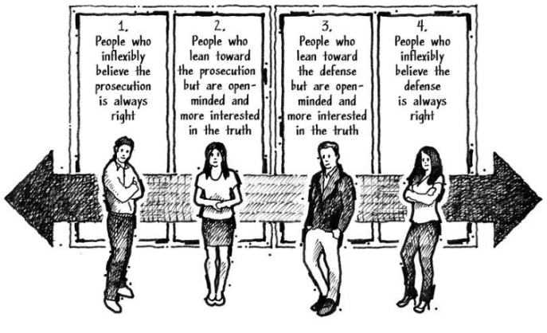
- Why is it important for convinced believers to know the evidence for Christianity?
  - ________________________________________________________________________________________________________________________________________________________________________________________________

- Why are young convinced believers in danger of slipping into “doubting believers”?
  - __________________________________________________________________________________________________________________________________________________________________
- What are the two most important scientific questions that caused prominent atheist Anthony Flew to move from convinced nonbeliever to doubting nonbeliever to theist?
  - ____________________________________________________
  - ____________________________________________________
- Speaking of ‘convinced nonbelievers’, Wallace writes, “Until a person in group 4 migrates into group 3, he or she will be far more likely to __________ Christian case makers than __________ to the Christian case.”
- How should we respond when we encounter ‘convinced nonbelievers’? Wallace says, “Whenever I become frustrated with people in group 4 … I ask myself, ‘When was the last time I __________ for this person and asked God to __________ this __________?
- Extra credit: Do you agree with Wallace when he says, “I’m watching for God’s activity in their lives [group 4 nonbelievers] and waiting for an opportunity to be a good Christian case maker.” ? Why or why not?
  - ________________________________________________________________________________________________________________________________________________________________________________________________________________________
- “If there’s one thing every Christian case maker needs to understand about the opposition’s response, it’s this: don’t be shocked that the other side can make a __________ persuasive argument. The fact the opposition can make a case doesn’t mean it’s __________.”
- Wallace says, “I’ve learned to __________ a strong case from the opposition, but I know an argument is not __________; a presentation is not a __________.”
- “Don’t assume something is true just because someone with authority says it, suggest it, or makes a case for it. … Connect the __________. Use your __________ __________,.”
  - “That’s why we need to help people understand: Everything counts as __________, including the __________of the original witnesses; the testimony of those who __________to the statements of these witnesses; the corroborative evidence of ______________; the internal confirmation of ______________, __________, and proper __________; and the ______________of alternative explanations.”
- “ … there are only two possible categories of explanation fo the evidence we see in the universe: …” What are the two categories?
  - ______________________________
  - ______________________________
- Why do atheist have “an equal burden of proof to demonstrate their ‘suspect’ is the best explanation.” ?
  - __________________________________________________________________________________________________________________________________________________________________
- Why are possibilities irrelevant?
  - _________________________________________________________________________________________________________________________________________________________________

- Most of us are familiar with ‘multiverse theories’ that have been offered to explain the fine-tuning we see in the universe … [and] ‘string theories’ … that have been offered to explain the origin of the universe. Both of these naturalistic theories … are popular among atheists, but they are highly _____________. … ____________by both theistic and atheistic physicists for their lack of evidential __________.”
- (a) Are the theories in the previous question possible? (b) Are they evidentially reasonable?
  - ________________________________________________
  - ________________________________________________
- What does Wallace mean when he says, “I allow the 99 pieces to inform the one rather than allow the one piece of evidence to inform the 99.”
  - ____________________________________________________________________________________________________________
- Why is the question of faith vs. works a good example of the importance of the answer to the previous question?
  - ____________________________________________________________________________________________________________
- What is the four part template for testing the reliability of eyewitnesses?
  - ______________________________________________________
  - ______________________________________________________
  - ______________________________________________________
  - ______________________________________________________
- Wallace tells us to be able to explain that “an eyewitness can be ________ about a particular detail and still be considered ________.”
- Wallace affirms the inerrancy of Scripture … “even if there may ________ to ‘contradictions ‘ to those who are ______________ with eyewitness testimony.”
- “Reliable eyewitnesses seldom appear to ________. … often raise ________ … are sometimes ___________.

