Discussion Questions: Chapter 3 – INTENSE INVESTIGATIONS
- Chapter Overview - What are the 5 practices to help you examine the claims of Christianity like a good detective?
  - __________________________________________________
  - __________________________________________________
  - __________________________________________________
  - __________________________________________________
  - __________________________________________________
- Do you agree with the R C Sproul quote at the beginning of chapter 3? Why?
  - ____________________________________________________________________________________________________________________________________________________________
- Wallace tells the story of the evidence that supported the murder conviction of Michael Lubahn. Why was Wallace so confident when others doubted Lubahn’s guilt?
  - ____________________________________________________________________________________________________________________________________________________________
- “Evidential confidence is often the result of investigative _________________.”
- “Our Christian confidence can be … bolstered if we apply a little investigative _________________ to our daily lives as Christ followers. Once we’ve accepted our evidential _________ and embraced a commitment to _________________, we need to learn how the _________________ like detectives.”

- What advice does Wallace offer to help us “read our ‘casebook’ [the Bible] ‘all the way through’ – thoroughly and effectively?
  - ______________________________________________
  - ______________________________________________
  - ______________________________________________
  - ______________________________________________
  - ______________________________________________
- In your own words: Why is it important to “Think about the evidence for God and the Bible broadly”?
  - ________________________________________________________________________________________________________________________________________________________________________________________________________________
- “Extraordinary claims require extraordinary evidence.” In what way does this seem to be a reasonable claim?
  - ____________________________________________________________________________________________________________________________________________________________
- In what way is that claim not valid?
  - ____________________________________________________________________________________________________________________________________________________________
- “FSA is an approach to examining the _________________ used by witnesses and suspects in an effort to identify “_________________ indicators” and other important _________________.”

- “Skeptics sometimes point to differences between the gospel accounts as evidence of their unreliability.” How did Wallace respond to the presence of those differences when he first read the gospels as an atheist?
  - ________________________________________________________________________________________________________________________________________________________________________________________________________________
- “The Gospels possess many of the same characteristics seen in other _________________ eyewitness accounts. While each account, read in isolation, may _________________ a question, when all the statements are assessed together, we begin to understand the _________________ of what _________________.”
- “While investigating a cold case, I make dozens of ________, and these ________ generally fall into _______ distinct categories: _________________ and _________________. Cases are solved when _______ of the explanations on my list accounts for _______ the evidence on my other list. This process is called “_________________ reasoning” …”
- If someone claims that Jesus never claimed to be God, what evidence should you cite to the contrary? (He made claims about the following.)
  - ___________________________________________________
  - ___________________________________________________
  - ___________________________________________________
  - ___________________________________________________
  - ___________________________________________________
- What does Wallace mean by “add to the case evidentially”?
  - ________________________________________________________________________________________________________________________________________________________________________________________________________________
- Do you agree that we should sometimes consider extra-Biblical evidence for Christianity? Why?
  - ____________________________________________________________________________________________________________________________________________________________
- “If someone were to ask you, “Why do you believe Jesus actually lived and that you can trust what the Bible says about him?” you could now respond by way of a summary: If every Bible ever printed was destroyed and the only ancient documents we had mentioning Jesus were those written by _________________ non-Christians, we’d still know the following:
  - Jesus was a real _______ who lived in _________________. He was reportedly born of a _________________ and had an earthly father who was a carpenter.
  - He lived in _________________, in the region known as Palestine.
  - He was wise and _________________.
  - His teaching was so _________________ that He developed a large _________________ of Jewish and Gentile _________________.
  - He taught His disciples to live with the same _________________ He exhibited, and His _________________ code was exceedingly high. But Jesus was more than a _________________ teacher:
  - He possessed “_________________ powers” and had the ability to predict the _________________ accurately.
  - His supernatural acts and teachings persuaded many _______ to walk away from their __________.
  - Jesus claimed to be _______, and His disciples readily _________________ this claim.
  - The Jewish leadership ultimately brought _________________ against Jesus based on His _________________ and _________________.
  - He was prosecuted and _________________ under Pontius Pilate, during the reign of _________________ Caesar.
  - There was an _________________ and _________________ at the point of the execution.
  - Jesus’s followers reported _________________ Him resurrected three days after the crucifixion, however, and Jesus even showed them His _________________.
  - His followers _________________ the resurrection _________________ Jesus was the Messiah.
  - They adopted Jesus’s moral teaching and lived their lives accordingly, holding to their belief in His _________________, even though it meant they would _________________ greatly at the hands of the Roman Empire. They were ultimately _________________ for their faith in Christ.”
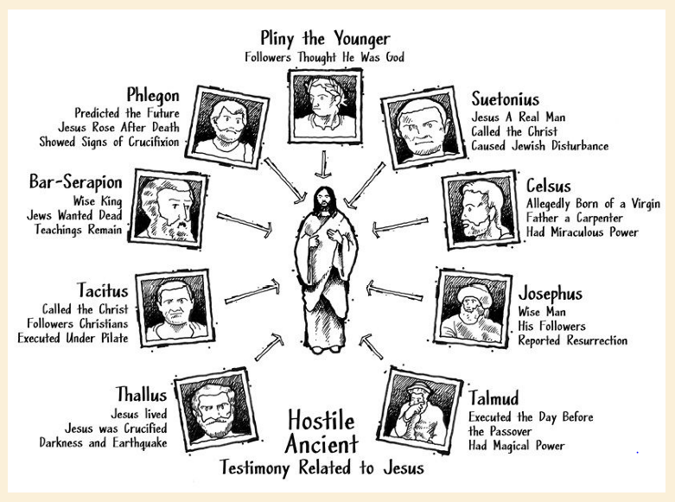
- “The case for the historicity of Jesus is strong. The record found _________________ the Christian “casebook” is a _________________ account of Jesus’s life and ministry, and it is _________________ by the passage of time as additional evidence emerged _________________ the book.”
- “Current discoveries in science and philosophy only strengthen the case for God’s existence.” What 4 categories does Wallace use for his list of these discoveries?
  - ____________________________________________________
  - ____________________________________________________
  - ____________________________________________________
  - ____________________________________________________
- “The special _________________ of the Bible is consistent with and confirmed by the natural _________________ of the world surrounding us. The case made from inside the Christian ‘casebook’ is made even _________________ by the evidence we find _________________ the book.”
- Scientific experiments provide us with _______. Historical investigations provide us with _______. The raw data and facts don’t __________, _______, or _______ us anything. Observers and thinkers _________________ the data and facts, _________________ them, and provide ‘_________________’ and ‘_________________.’ The problem, of course, is that observers and thinkers … hold presuppositions, and these presuppositional _________________ affect the way they form _________________.”
- What is the point of the comparison of Bruce Metzger and Bart Ehrman?
  - ____________________________________________________________________________________________________________________________________________________________

